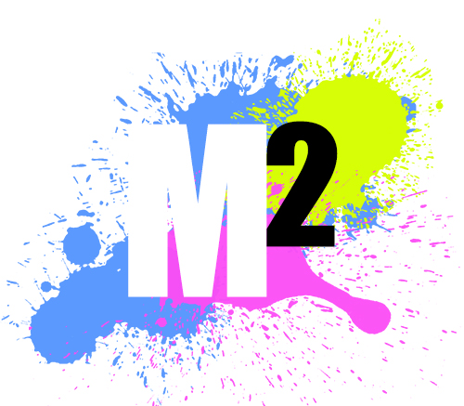

Q1. What is your company/organisation name?

Q2. What does your company/organisation do?

Q3. Is this a new or replacement site? (If new, go to Q9)

If replacement…

Q4. What is the current domain (URL)?

Q5. What is your motivation for changing to a new site?

Q6. What do you like/dislike about your current site?

Q7. Can you give details of existing analytics, account access or reports below:

Q8. Do you need a development site/testbed during build?

Q9. What are your organisational goals for the website – what do you want to achieve with the site? (Goals should be SMART: specific, measurable, achievable, realistic and have a timeframe)

Q10. Who is your target audience/audiences? (Perhaps more than one (new customers and existing customers for example). Do you have an ideal customer profile?)

Q11. What will they come to your website for? (Information/contact details/pricing/sign up)

Q12. What are the main categories you’d like to feature on the site – from most important to least. (These will become the site map). (For example: About our business, Our products, Pricing, Sign up & Contact details)

Q13. Do you have any existing content available to tell the story? (photos, videos, text, diagrams, etc) If so, what?

Q14. Who is going to create content for the new site? Will it be done with Search Engine Optimisation in mind? (See section below)

Q15. What do you want people to do when they get to the site? (Buy from the shop/complete enquiry form/call us/read lots of articles/ sign-up to the newsletter?)

Q16. What are the two most important calls to action that will be on the home page? (Eg. Sign up for a course, Download a brochure)

Q17. Where does your target audience spend time online? Where will you be sharing your content (links on the page using Social Sharing to LinkedIn, Google+, Facebook, Twitter, etc). Do you have these channels set up already?

Q18. The list above, including content and calls to action, will give you a clear picture of what functions are required in the website, such as:

For example:
- Content management (to allow you to manage the content yourself)
- A blog
- Social media widgets for activity stream
- Members only content area (paid or free)
- E-commerce capabilities (with specific features, such as having specials, discounts, featured products, customer reviews, etc).
- Advertising or sponsors

Q19. Do you have any logos, colours, style/brand guidelines or marketing materials? (If so, what do you have? If not, do these need creating as part of the website build?)

Q20. If it’s a rebuild of your current site, what do you like/dislike about your current site?

Q21. List three websites with design ideas that you like (can be from anywhere)
1.
2.
3.
Q22. List the web addresses of up to three competitors’ websites
1.
2.
3.

Q23. Do you have or need a domain name and or hosting etc. If so, what are the details, and if not, what is your preferred domain name?

Q24. Do you have a set of priority keywords and phrases (for SEO)?

Q25. Will this (SEO) be considered in the content creation (in-house/by a specialist)?

Q26. How is performance going to be measured after launch? (What are the metrics & KPIs (Before and after analysis of traffic, site referral, conversions etc.)

Q27. What’s your budget? (Do you think this is realistic for the features and functions you want? What are the priority issues, and can it be staged if the budget doesn’t cover the wish-list?)

Q28. What is your deadline? Are there any other milestones that need to be achieved by certain dates?

Q29. Who will project manage from your end? Who is the main point of contact?

